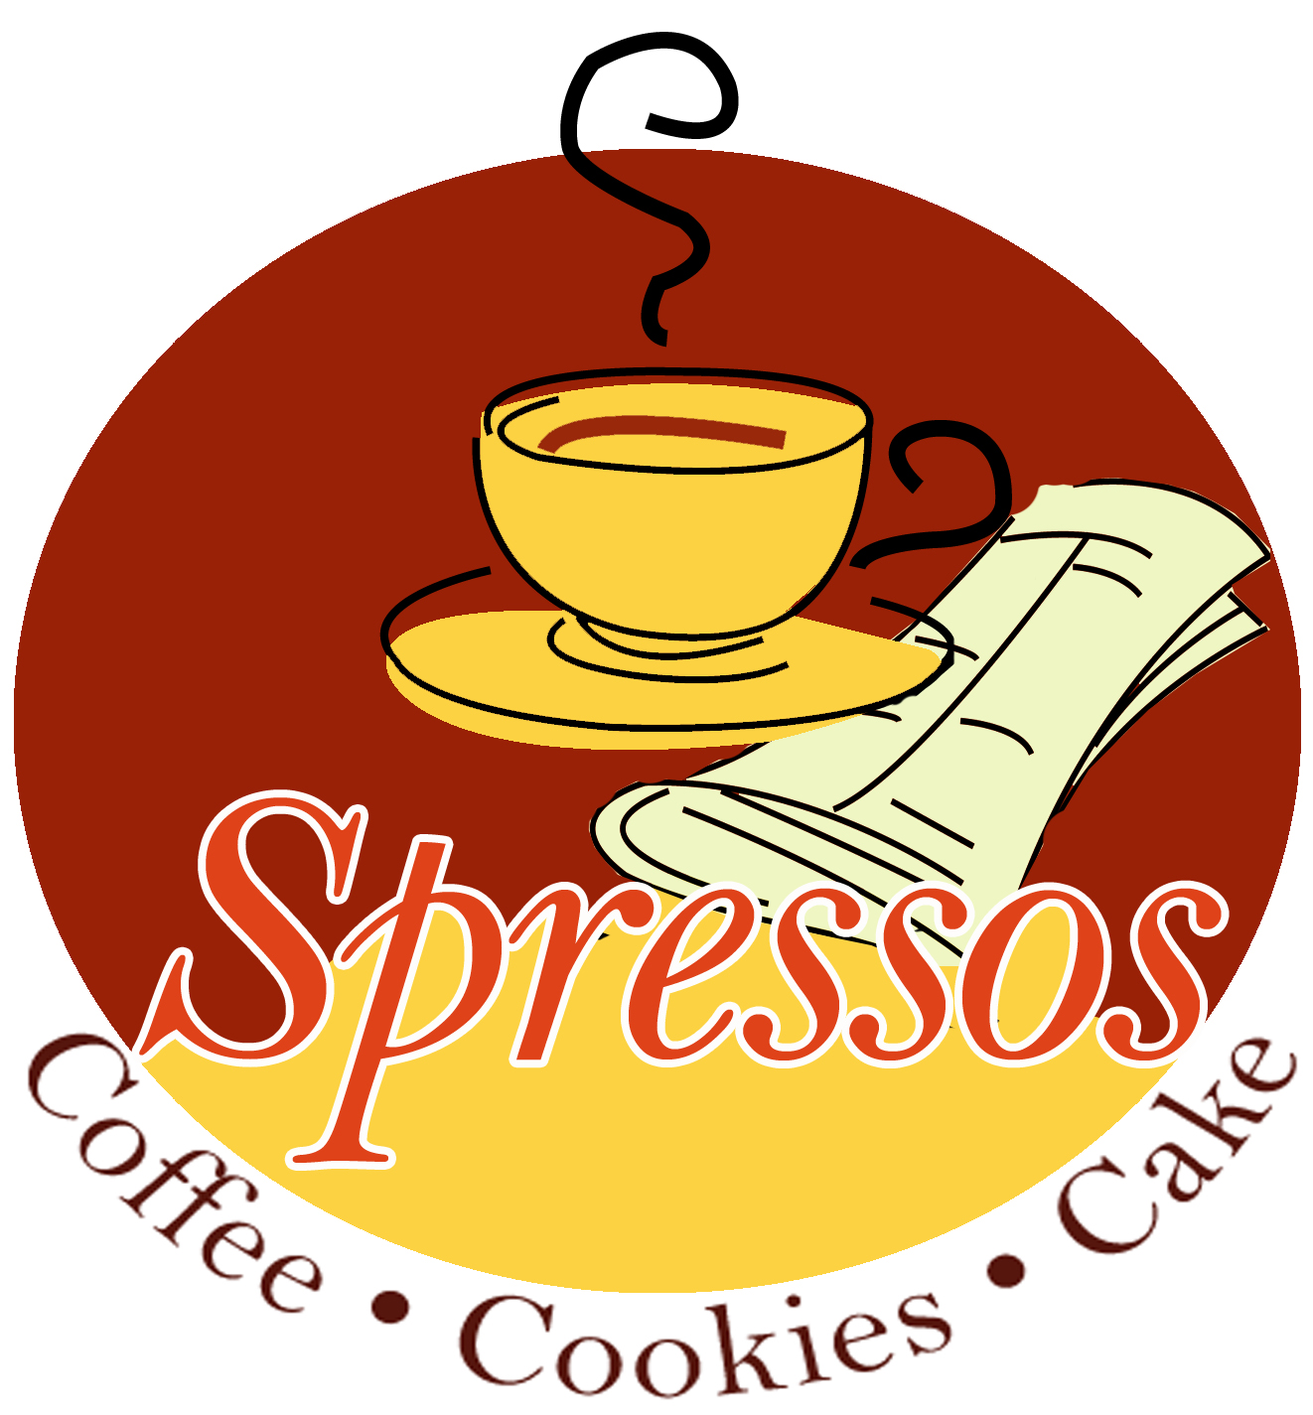

315-356-7106
160 Brooks Rd

Muffins
assorted …$15.95 per dozen.

Bagels (with cream cheese & butter)
assorted …$15.95 per dozen.

Scones: assortment of blueberry, raspberry white chocolate and apple cinnamon $14.95 dozen

Deluxe tray:
1 dozen (large) premium items such as croissants, cinnamon buns, danish & more……$22.95

Fresh Baked Quiche $15.95
Serves 6-8 people Choose From:
Broccoli & Cheddar
Spinach & Feta
Bacon & Cheddar
Artichoke with red pepper & Mozz

Miniature Pastry Trays
Assorted Mini-cheesecakes
Mini Cannoli, Baklava, assorted bars
$14.95 per dozen
(Minimum 2 dozen order)

Cookie Trays
Large tray $35.00 over 4 dozen
Small tray $22.95 over 2 dozen assorted flavors such as: Chocolate chip, peanut butter, iced sugar, oatmeal & more

Coffee Cakes $24.95 tube pan
Lemon Blueberry coffeecake
Cinnamon Streusel coffeecake
All-Butter Pound Cake
(need 48hrs notice)
Beverages
Treat your friends to our delicious full bodied coffee. Our coffee is fresh roasted to order every week by an artisan coffee roaster, it does not come from a warehouse.

Box of Coffee Togo
Holds 96oz of coffee……$16.95
Approx 10 cups

Deluxe Sliced Fruit Trays
Regular …….$48.00 (15-20ppl)
Large……..$58.00 (25-40ppl)

All our bakery items are made fresh to order please allow 1 days notice for most items.

All items will come bakery boxed unless Tray is specified.
Tray charge $3.50

Other Special bakery items may be available based on season. Please call for special orders.

- Large coffee server $35.00 (1.5 gallons) serves 15-25
- Small coffee server $16.95 (.75 gallon) serves 10-15
  - Includes cream/sugar/cups

www.spressos.com
315-356-7106

